IoT Air Quality Innovation Proposal

[Company name] | [Company address]

BLE IOt PROJECT PROPOSAL

Marco C, gABrIEL R, vALENTIN S, Niklas r

2021

Contents

Problem Statement 2

Main & Sub Research Question 2

Research Strategies 2

Air Quality Values per Zone 2

Expansion Possibilities 2

Network Device Location Map Zone TQ5 3

Network Device Location Map Zone R10 3

STAR Network Topology Zone TQ5 4

STAR Network Topology Zone R10 4

Implementation 5

Location 5

Example Data: 5

IoT Air Quality Innovation Proposal

# Problem Statement

This past year has been filled with restrictions and dangers due to the Pandemic. It is not safe to have many students grouped up in small spaces. With this project we aim to measure the quality of the air, PPM / VOC values, and display the data live using a Bluetooth Low Energy network.

# Air Quality Values per Zone

The idea of this project is to calculate the carbon dioxide levels in the floor of the school building. We will be using the ESP32 as a client and the Nordic Thingy:52, as well as the Raspberry Pi, as a Server. The idea was to collect as many values as possible and log them. Our proposal will be divided in steps:

1. Obtain the PPM values using an ESP from the Thingy:52
2. Obtain the PPM values using an ESP from multiple Thingy:52’s
3. Write the obtained values to the Raspberry Pi
4. Log the values from the Raspberry Pi to a database’
5. Visualize the values from the Raspberry Pi using D3js or Grafana

We want to use BLE in this project since we got acquainted with the GATT Server architecture. The Thingy:52 has an environmental service with multiple characteristics; each characteristic provides a sensor value that can describe the environment (Example: Temp, Hum, CO2…).

# Expansion Possibilities

This could be an interesting project for future Smart industry students to pick up. This semester was filled with unknowns and time was a constraint. Possible expansion possibilities are to create a meshed network with the ESP32’s and avoid centralizing the Raspberry Pi to be in range of all ESP’s. The code could be improved to be “Plug and Play” and it could be expanded by adding a camera and counting how many people are in the area with tensor flow (or other libraries). This could improve the accuracy of the “danger meter” as it could correlate the air quality with number of people in the area.

# Network Device Location Map Zone TQ5

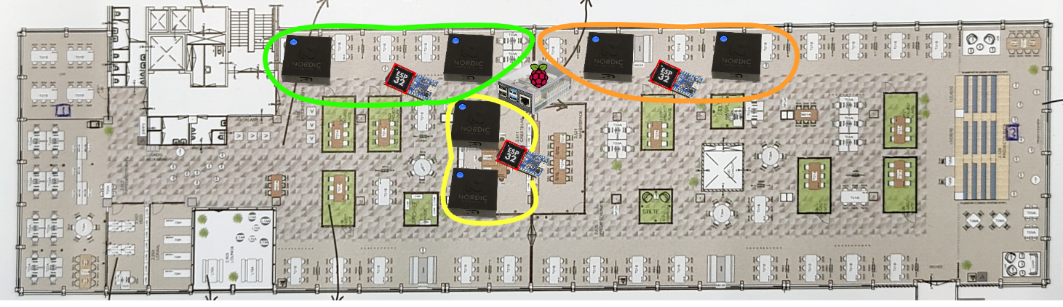

# Network Device Location Map Zone R10

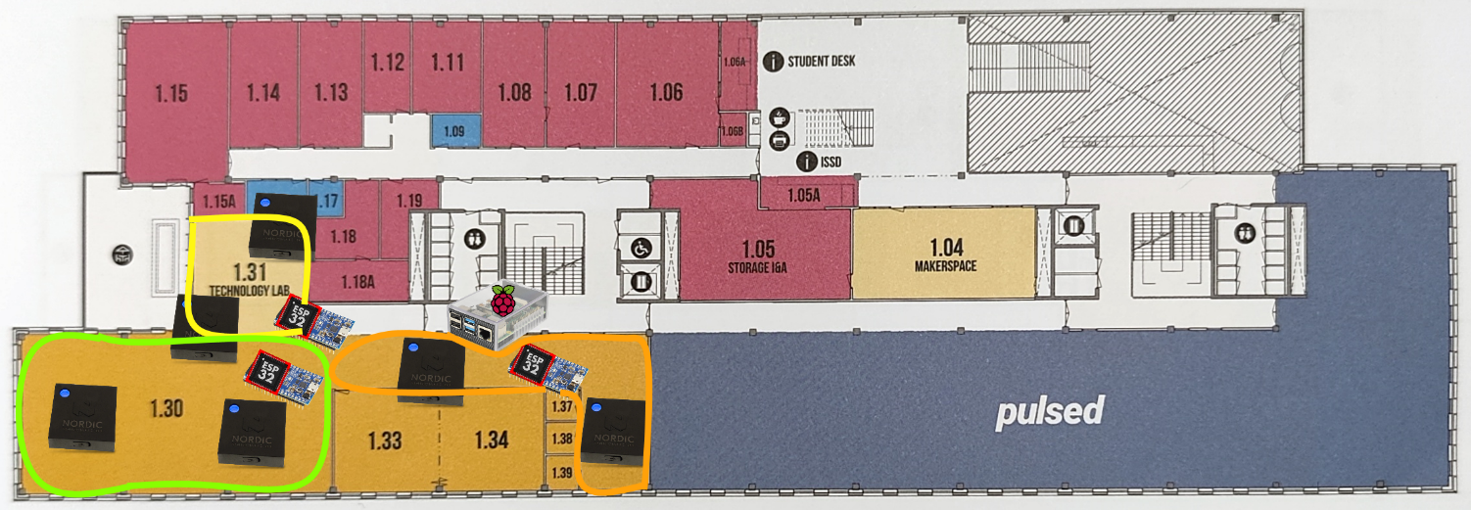

# STAR Network Topology Zone TQ5

# STAR Network Topology Zone R10

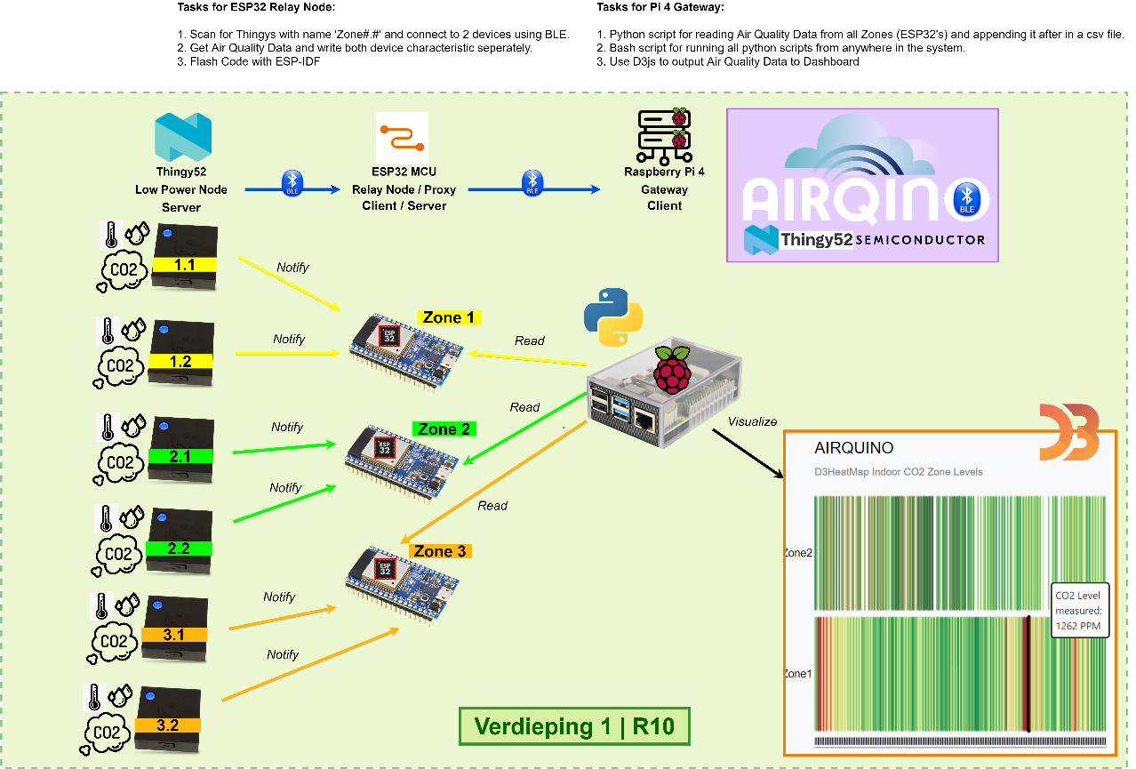

# Implementation

## Location

After setting up the network in school, we will now collect data for multiple days to be able to visualize the data. The ESPs manage to advertise the data collected from the Thingy:52 correctly, and the Raspberry PI, acting as a gateway, is logging the data correctly. The next step would be to setup the graph to use live data but that will be completed in the Data / HMI Module mini project.A picture containing diagram

## Text Description automatically generatedExample Data:

This data format will help us differentiate the zone where the device is and we can display it with a corresponding color. We will like to have a dashboard where you could choose to display the desired zones and sensor values (both values can be selected at the same time).